

[Exam 1]

**Question Set B**

|  |  |
| --- | --- |
| **Instructor:** | Ashrafur Rahaman |
| **Class:** | 2020W CSD 2214 2 |

|  |
| --- |
| * Read all questions carefully. * Partial marks may be awarded where appropriate. * Time allowed:90 minutes * Total marks: 20 |

|  |  |
| --- | --- |
| **Date:** | 7-March-2020 |
| **Student Name:** | Sharanpreet Kaur |
| **Student Number:** | C0758580 |

**Exam Rules:**

1. You need to solve two problems in your computer.
2. You must create a folder in your computer named “2214-Exam1-YourStudentID”
3. Create two folders named (YourStudentID-Answer1 and YourStudentID-Answer2) inside the folder “2214-Exam-YourStudentID”
4. Inside “YourStudentID-Answer1” folder you will have HTML file named “YourStudentID-A1.html”
5. Inside “YourStudentID-Answer2” folder you will have HTML file named “YourStudentID-A2.html”
6. You can create JS, CSS, Image or any other folder you need or like inside “YourStudentID-Answer1” and “YourStudentID-Answer2”
7. Do not use any online JavaScript/CSS framework and/or library.

**How to submit your exam paper:**

1. Write Answers and add screen shot in this document.
2. Copy this document file (including your answer) into “2214-Exam1-YourStudentID” folder.
3. Compress the entire folder and upload in moodle.

**Question 1 (10 Marks)**

**User JQuery and JQueryUI library to solve this problem. Ensure that JQuery, JQUery UI framework files are downloaded to your local computer.**

Create a JQuery UI Tab with 4 sections in it. The ID of the tab must be “YourStudentID-mytab” (2 marks)

Tab must have “Collapse Content” option (1 mark)

Tab must have “Open on mouseover” option (1 mark)

Inside Section 1 of the tab enter 3 textbox named “YourStudentID-FirstName”, “YourStudentID-LastName”, “YourStudentID-DOB”. For YourStudentID-DOB use datepicker widget. (1 mark)

Inside Section 2 of the tab enter 2 images. (1 mark)

Inside Section 3 of the tab enter 2 button “OK” and “Cancel”. For both of the button use jQuery UI “Button” Widget (1 mark)

When you click on “OK” button a JQuery Dialog will come up. (1 mark)

**Answer here:**

Explain your answer (2 marks).

Screen shot of the following things need to be added:

1. HTML Code

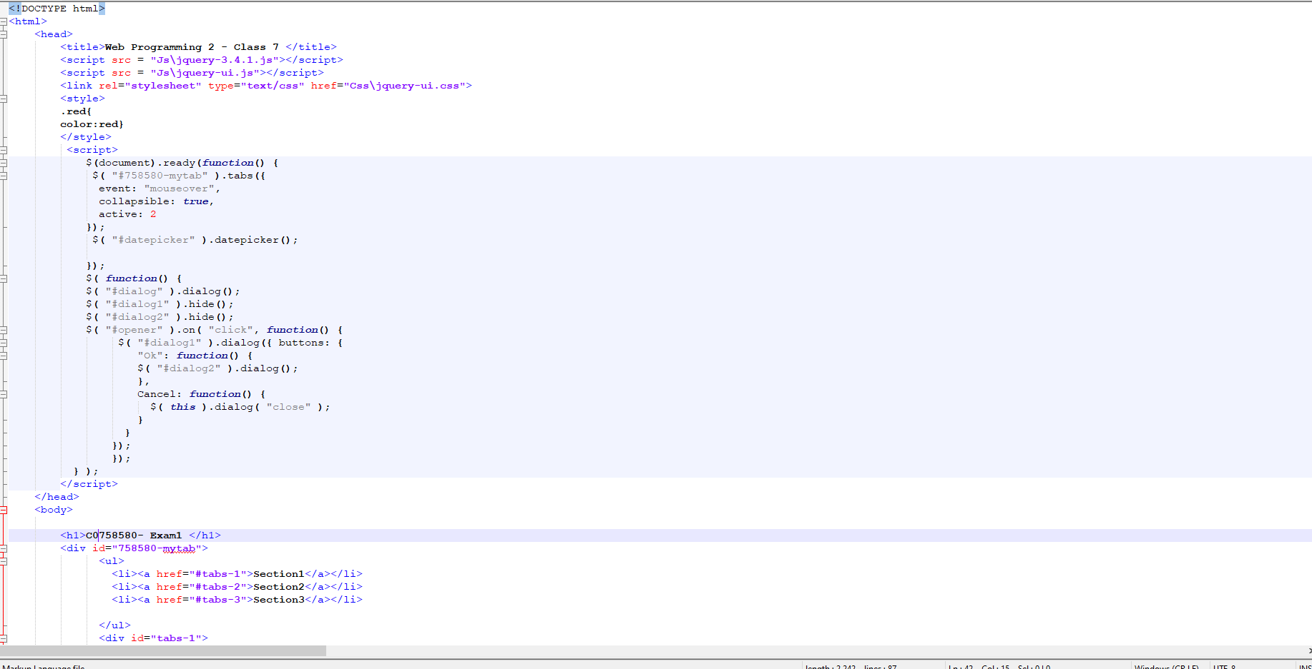

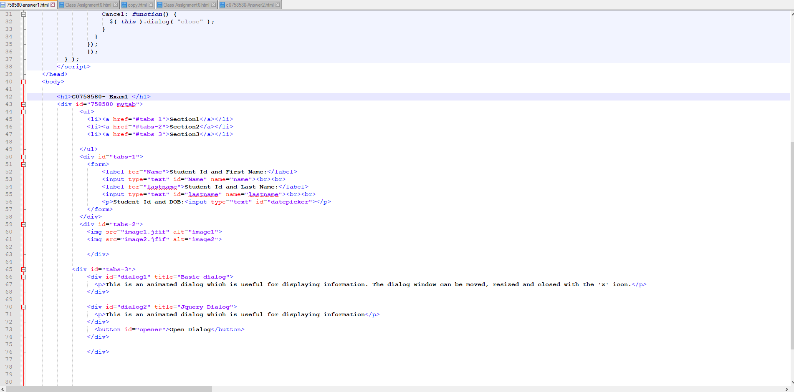

1. JS Code

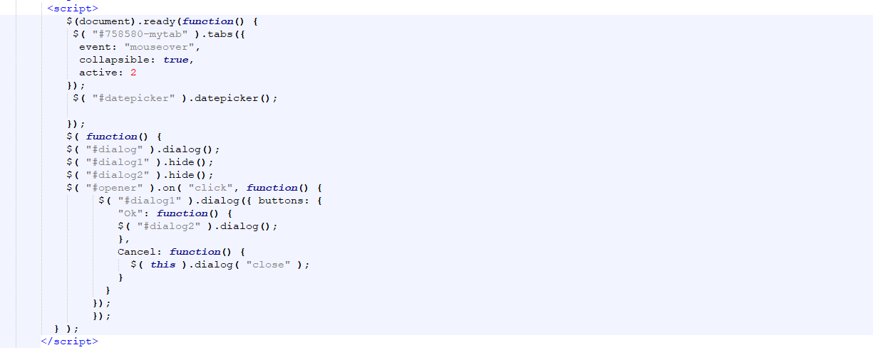

1. Output Screen when page loads

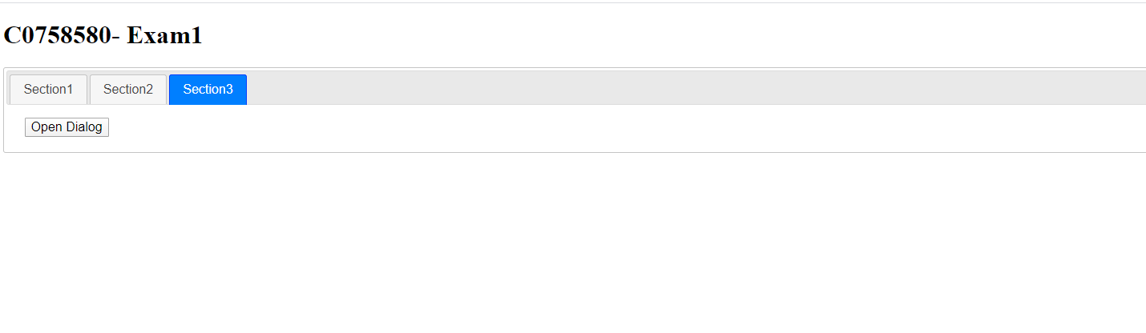

1. Output screen of each tab

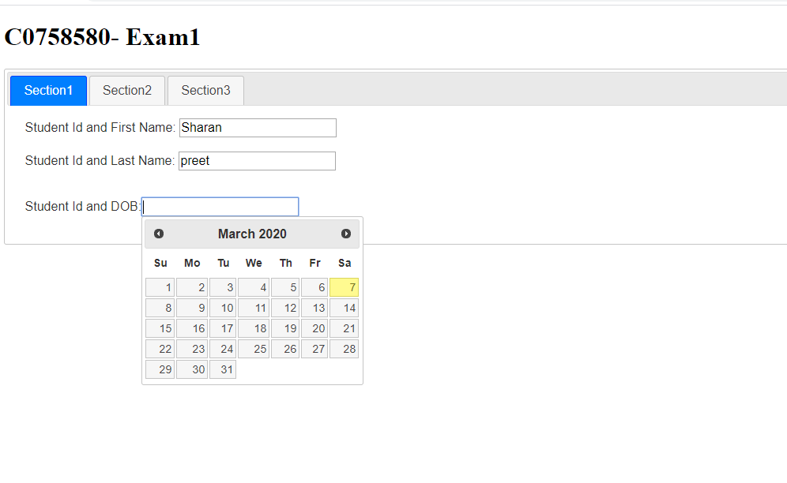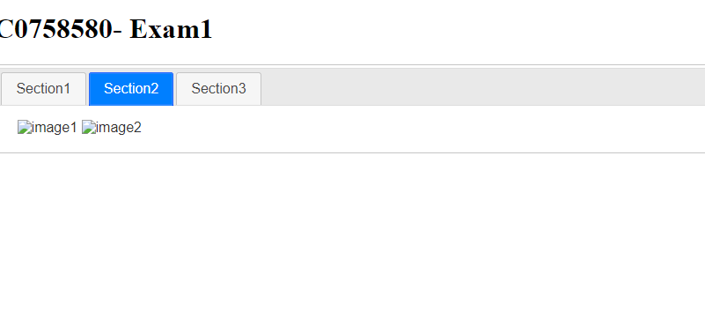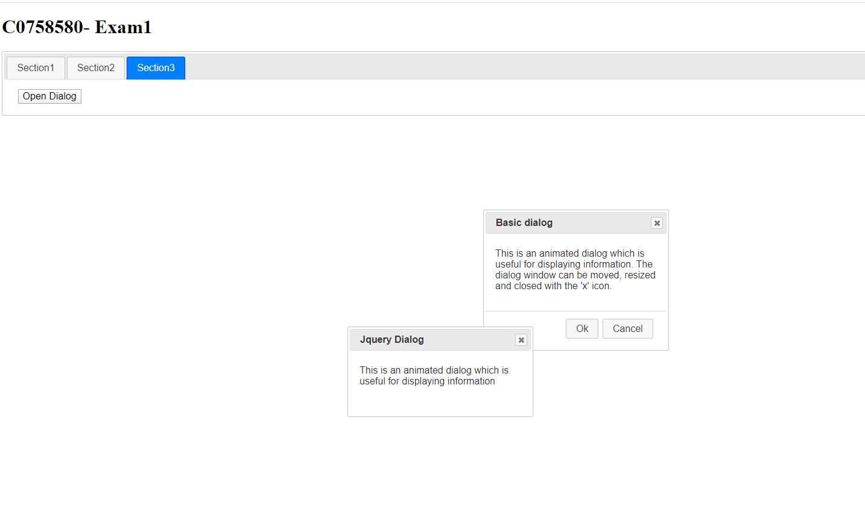

**Answer:**

**Question 2 (10 Marks)**

**Solve this problem using HTML, CSS, and JavaScript. Do not user JQuery Library.**

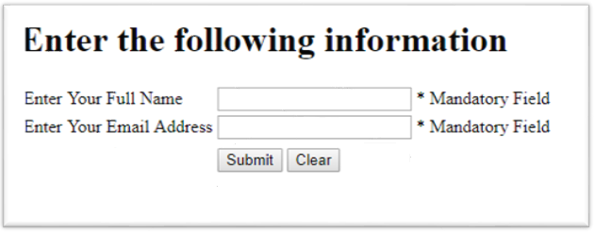

Create HTML page like above. The ID of the textboxes will be “*YourStudentID_FullName*”, “*YourStudentID_Email*”. For “* Mandatory Field” use span and **do not use any ID**. (2 marks)

Write JQuery Codes for the following actions:

1. When you click on submit button (4 marks)
   1. If *YourStudentID_Fullname* is empty then “* Mandatory Field” will be changed to “Please enter Full Name”
   2. If *YourStudentID_Email* is empty then “* Mandatory Field” will be changed to “Please enter Email Address”
   3. If both FullName and EmailAddress have value you will show the name, email address in a paragraph under the Submit and Clear button. The ID of the paraghaph will be “*YourStudentID_Output*”
2. When you click on the clear button (2 marks)
   1. “YourStudentID_FullName”, “YourStudentID_EmailAddress” will be empty
   2. “* Mandatory Field” text will be reset for both “YourStudentID_FullName” and “YourStudentID_EmailAddress”

**Answer Here:**

Explain your answer (2 marks).

Screen shot of the following things need to be added:

1. HTML Code

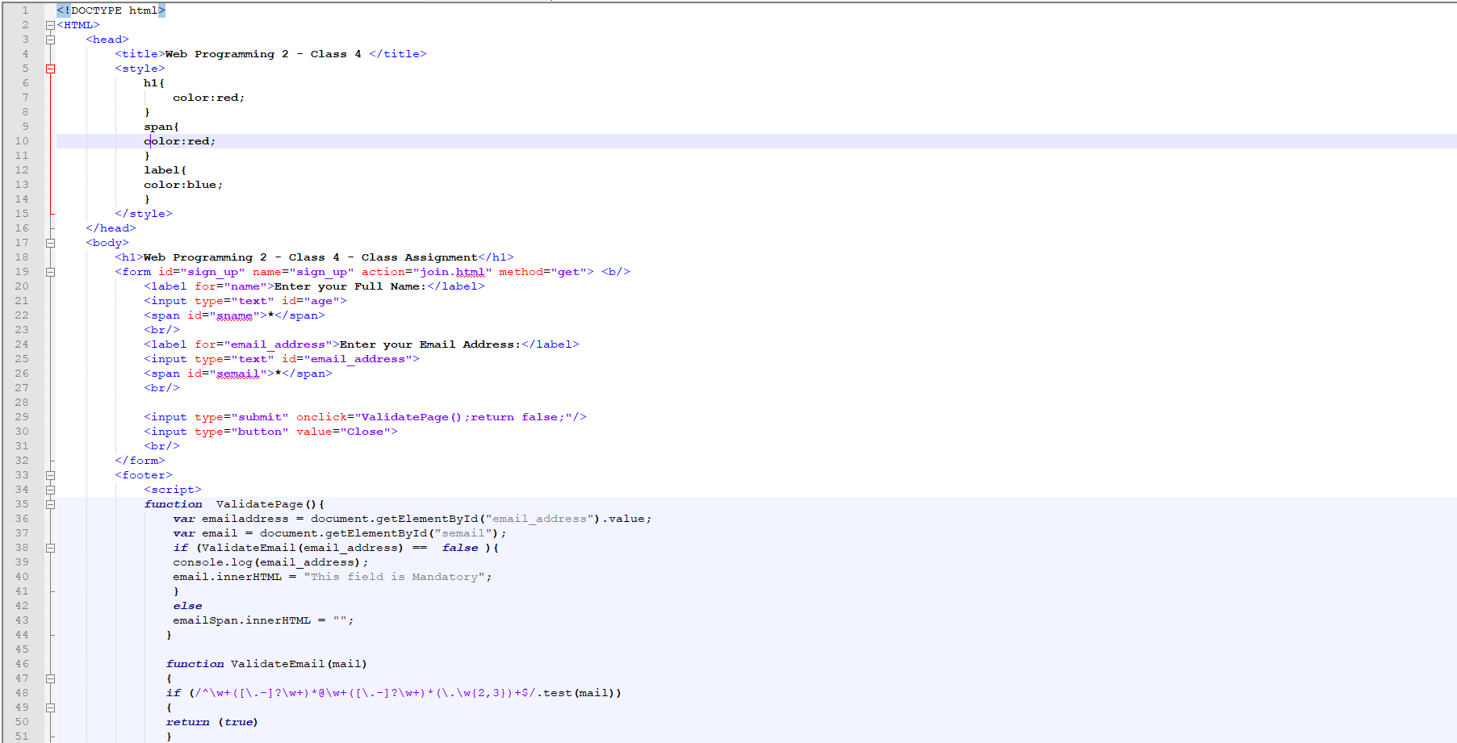

1. JS Code

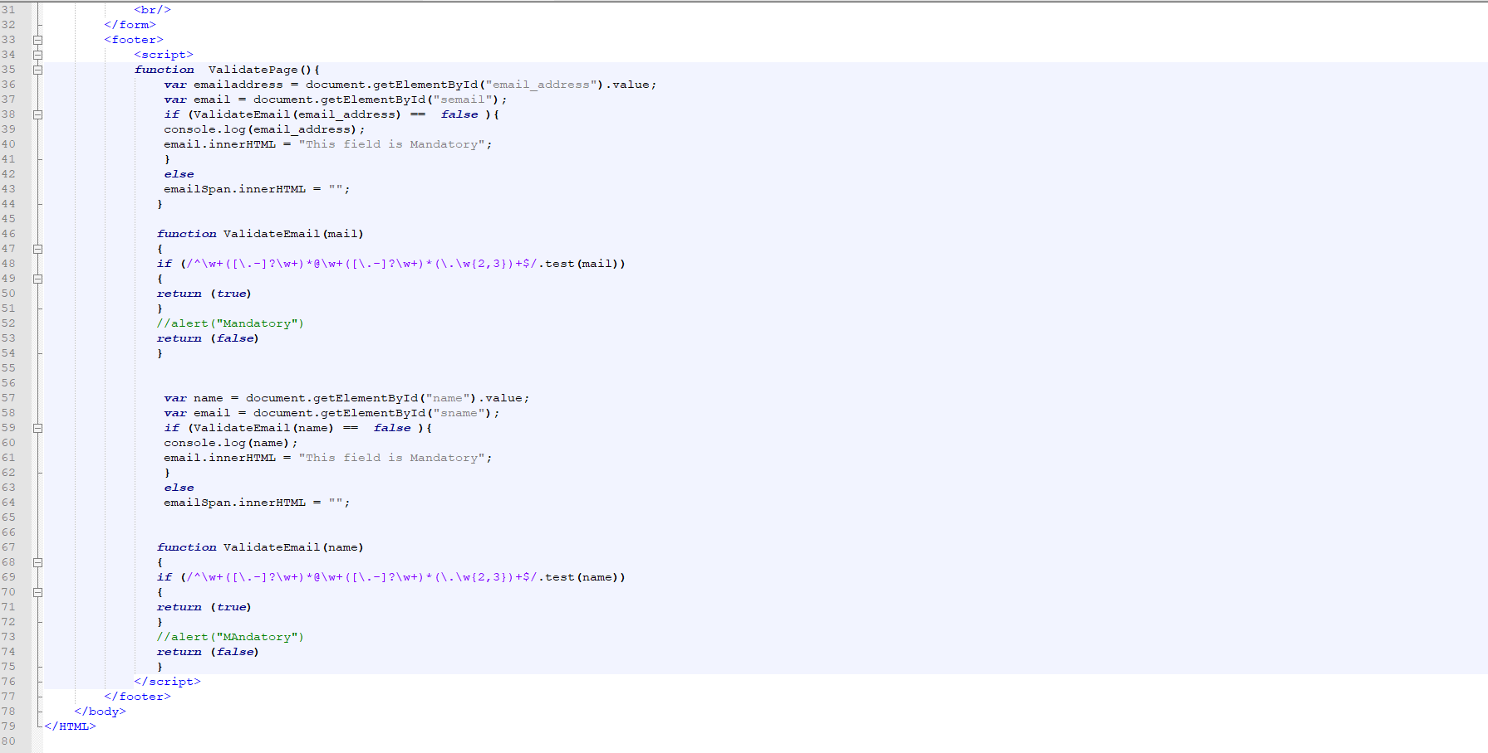

1. Screen shot of the page when first loads

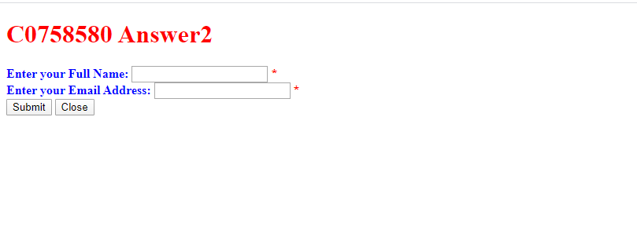

1. Screen Shot of the page when click on submit button (with validation and without validation)

